**Victory Saudi Arabia Launches the Next Generation of 2-Ton Diesel Commercial Trucks – 2026 Models**

In its latest appearance at the Victory Palace Hotel in Riyadh, *Victory Saudi Arabia* unveiled its 2026 models of next-generation commercial vehicles, now available through the exclusive dealer *Motiat Alkhair*.

The launch event was attended by a select group of transport and logistics experts, alongside major corporate representatives and distributors. Attendees were introduced to the new lineup, which combines efficiency, ease of use, and smart design tailored to meet the evolving needs of the Saudi market.

**International Presence and Future Vision**

The event welcomed a high-level delegation from *Victory Auto China*, led by Chairman Mr. MA. GUOLI and Mr. LI. XIN, General Manager of International Sales.

Speaking to the media, Mr. Ma emphasized the strategic importance of the Saudi market to Victory Auto—particularly in the commercial vehicle sector—given the Kingdom’s ongoing mega-projects and its role as host of global events such as Expo 2030 and the FIFA World Cup 2034.

He highlighted that *Victory Auto* places innovation and efficiency at the heart of its vehicle designs. The newly launched models have been engineered for long-term reliability to meet the expectations of Saudi customers, offering excellent fuel efficiency—making them an ideal choice for businesses of all sizes and individual operators. Mr. Ma also pointed out that these commercial vehicles support Saudi Arabia’s Vision 2030 sustainability goals by reducing carbon emissions.

All new *Victory J* models feature 4-cylinder diesel engines with 5-speed manual transmissions, delivering high fuel efficiency and dependable performance. The vehicles adopt a modern boxy design philosophy with sharp angles and bold front ends, giving them the initial impression of a pickup or SUV.

**A Strong Partnership Built on Trust**

Eng. Ahmad Bin Ali Al-Rubaish, General Manager of *Motiat Alkhair*, the exclusive dealer for *Victory Auto* in Saudi Arabia, emphasized:  
*"These new vehicles reflect the brand’s commitment to offering practical and economical solutions that cater to the needs of the Saudi market."*

Eng. Al-Rubaish elaborated that the relationship between *Motiat Alkhair* and *Victory Auto* is more than just a business partnership—it is a long-standing success story spanning over a decade. Throughout various challenges and market shifts, their journey has been grounded in mutual trust and a shared vision to provide the best for the Saudi automotive sector. Today, *Victory* vehicles have become a benchmark in the Kingdom’s commercial vehicle market.

This success was recently crowned with *Motiat Alkhair* being awarded the **World’s Best Sales Growth Award for 2024**, a testament to the fruitful collaboration.

Eng. Al-Rubaish further reaffirmed the company’s unwavering commitment to delivering top-tier after-sales services, including the provision of genuine spare parts, advanced maintenance solutions, and continuous technical support. Through these efforts, the company aims to strengthen customer trust and deliver a seamless experience that reflects the brand’s quality and solid customer relationships.

Currently, *Motiat Alkhair* is expanding its integrated network of service and customer support centers across the Kingdom, ensuring easy access, rapid response, and comprehensive technical and logistical solutions for all *Victory Auto* clients.

**Conclusion**

This launch marks another significant milestone in *Victory Saudi Arabia’s* journey, reinforcing its growing presence in the commercial vehicle sector—where performance meets practicality.

Would you like this press release formatted for a media kit or adapted into a shorter press announcement for social media or internal use?

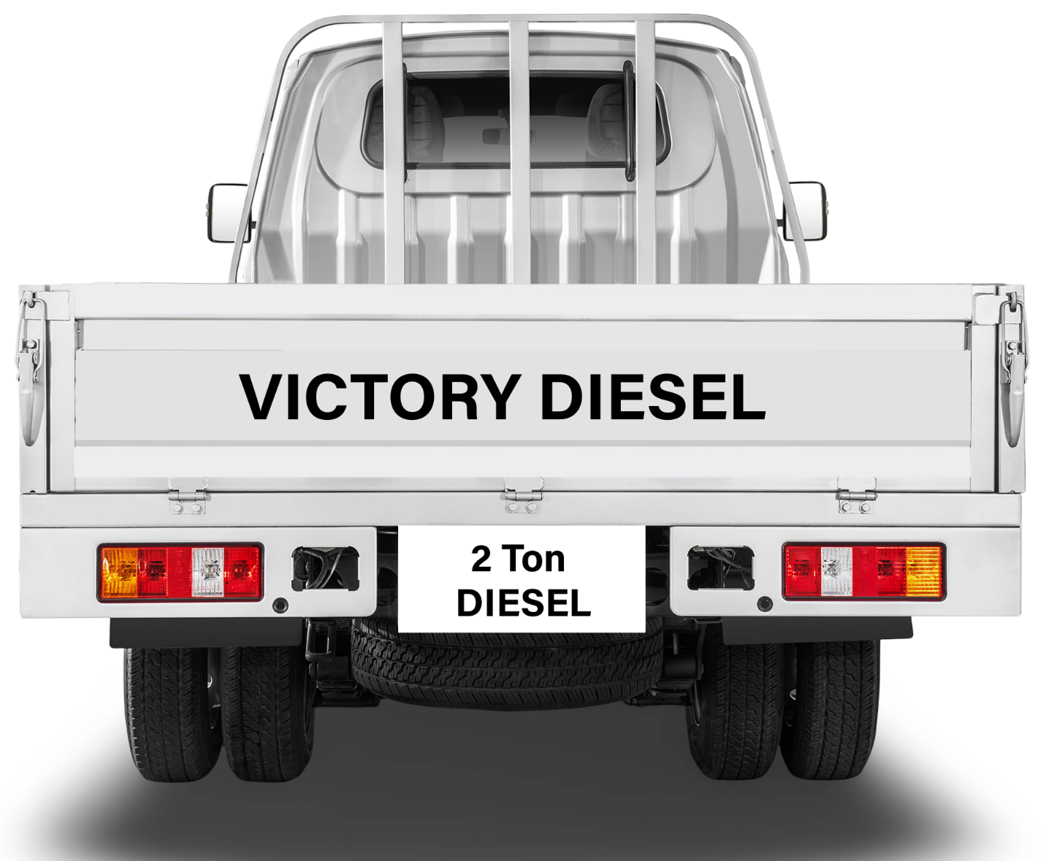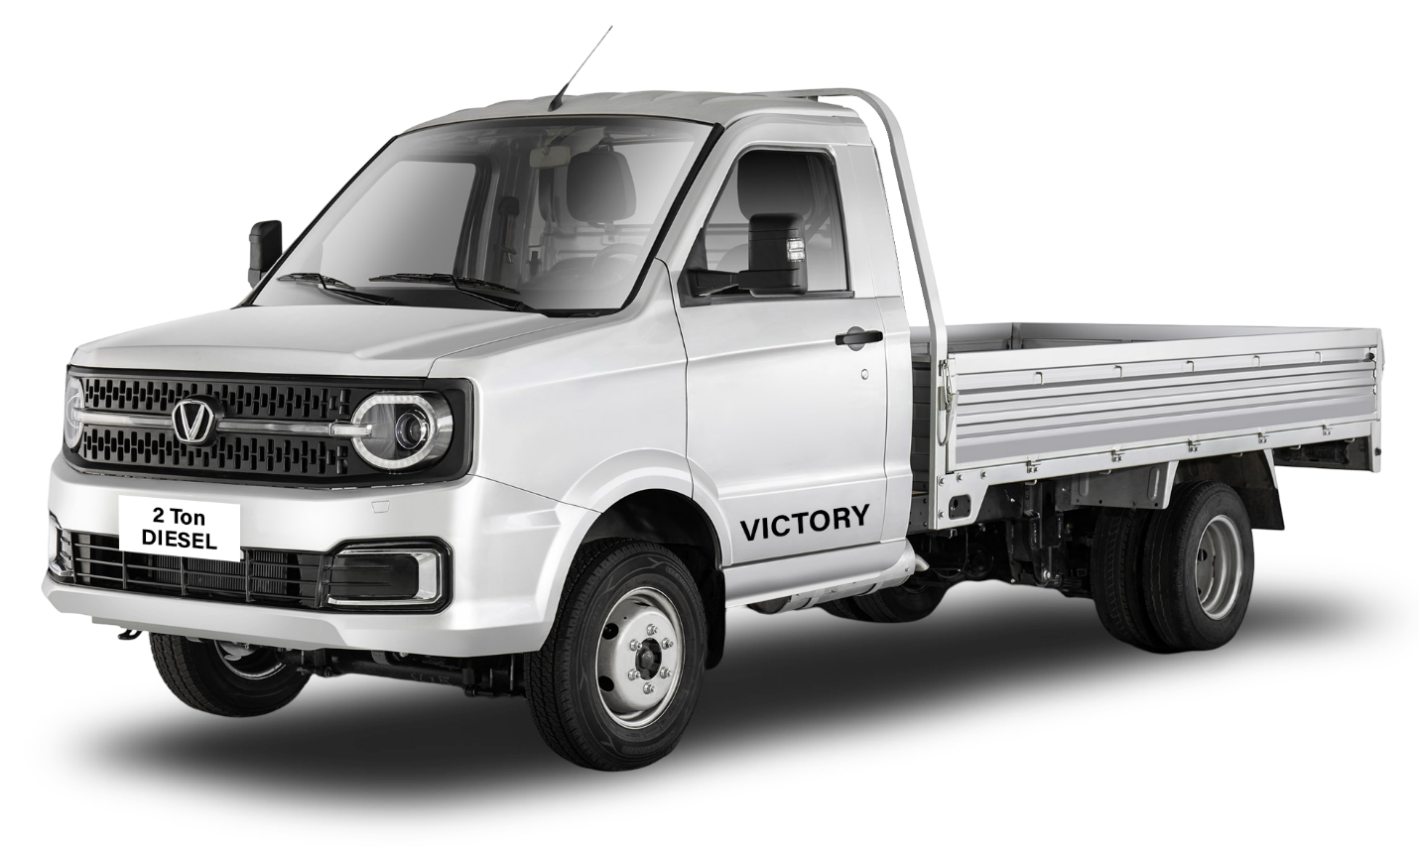**J3 – Victory Single Cab Diesel Truck – 2026**

**J4 – Victory Double Cab Diesel Truck – 2026**

